Tokenless Dining Management System Challenge
Team Name: One_Zero
Date: November 2025

1. Introduction
The Tokenless Dining Management System automates dining operations without physical tokens. It uses ID/PIN authentication, RFID card access, and presence detection to manage access, ensure security, and save power.
Key Features: - Multi-user PIN system
- RFID-based card authentication
- IR sensor for presence detection & deep sleep
- LED indications for access
Image placeholder: Optional background image of a cafeteria or ESP32 board.

2. System Components
- ESP32 / Arduino
- 2x2 Keypad for PIN entry
- MFRC522 / RFID Reader
- IR Sensor (PIR)
- LEDs for notifications
- OLED/TFT Display (optional)
- Power supply
Image placeholder: Block diagram of ESP32 with arrows to all connected components.

3. Module 1: Multi-Person PIN System
#include <Keypad.h>
#define LED_PIN 4
#define LIGHT_TIME 3000
const byte ROWS = 2;
const byte COLS = 2;
char keys[ROWS][COLS] = {{'1','2'},{'4','5'}};
byte rowPins[ROWS] = {12, 13};
byte colPins[COLS] = {14, 15};
Keypad keypad = Keypad(makeKeymap(keys), rowPins, colPins, ROWS, COLS);
String passPiyal = "1245";
String passOrpon = "2514";
String passNihal = "4152";
String input = "";
void resetInput() { input=""; }
void setup() {
Serial.begin(115200);
pinMode(LED_PIN, OUTPUT);
digitalWrite(LED_PIN, LOW);
Serial.println("=== MULTI PERSON PASSWORD SYSTEM ===");
Serial.println("Enter 4 keys...");
}
void loop() {
char key = keypad.getKey();
if (key) {
Serial.print("*");
input += key;
if (key!='1' && key!='2' && key!='4' && key!='5') {
Serial.println("\n[X] Wrong Key! Resetting...");
resetInput();
return;
}
if (input.length() == 4) {
Serial.println();
if (input == passPiyal) {
Serial.println("[OK] Piyal Access Granted");
} else if (input == passOrpon) {
Serial.println("[OK] Orpon Access Granted");
} else if (input == passNihal) {
Serial.println("[OK] Nihal Access Granted");
} else {
Serial.println("[X] Wrong Password! Enter your right Password:");
resetInput();
return;
}
digitalWrite(LED_PIN, HIGH);
delay(LIGHT_TIME);
digitalWrite(LED_PIN, LOW);
resetInput();
}
}
delay(20);
}
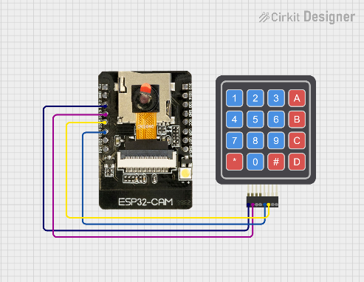
Image placeholder:

4. Module 2: IR Sensor with ESP32-CAM & Deep Sleep
#include "esp_camera.h"
#include "driver/rtc_io.h"
#define SENSOR_PIN GPIO_NUM_14
#define LED_PIN GPIO_NUM_4
#define IDLE_TIMEOUT_MS 5000
#define SENSOR_ACTIVE_LEVEL LOW
#define SENSOR_IDLE_LEVEL HIGH
unsigned long lastActivityTime = 0;
void setup() {
Serial.begin(115200);
gpio_hold_dis(LED_PIN);
gpio_deep_sleep_hold_dis();
pinMode(LED_PIN, OUTPUT);
pinMode(SENSOR_PIN, INPUT_PULLUP);
digitalWrite(LED_PIN, HIGH);
lastActivityTime = millis();
esp_sleep_wakeup_cause_t cause = esp_sleep_get_wakeup_cause();
if (cause == ESP_SLEEP_WAKEUP_EXT0) {
Serial.println(">>> WOKE UP via IR INTERRUPT! <<<");
} else {
Serial.println(">>> Normal Power On <<<");
}
}
void loop() {
int sensorState = digitalRead(SENSOR_PIN);
if (sensorState == SENSOR_ACTIVE_LEVEL) {
lastActivityTime = millis();
digitalWrite(LED_PIN, HIGH);
Serial.println("Motion Detected: Active");
} else {
unsigned long currentMillis = millis();
if (currentMillis - lastActivityTime >= IDLE_TIMEOUT_MS) {
enterSleepMode();
}
}
delay(50);
}
void enterSleepMode() {
Serial.println("Idle timeout reached. Engaging Interrupt System & Sleep...");
digitalWrite(LED_PIN, LOW);
int wakeLogic = (SENSOR_ACTIVE_LEVEL == LOW) ? 0 : 1;
if (rtc_gpio_is_valid_gpio(SENSOR_PIN)) {
esp_sleep_enable_ext0_wakeup(SENSOR_PIN, wakeLogic);
Serial.println("Interrupt Configured on Pin 14.");
}
gpio_hold_en(LED_PIN);
Serial.println("Sleeping...");
Serial.flush();
esp_deep_sleep_start();
}
Image placeholder:

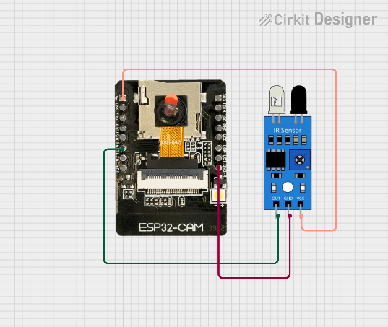

5. Module 3: RFID Access System
#include <SPI.h>
#include <MFRC522.h>
#define SS_PIN 2
#define RST_PIN 12
#define LED_PIN 4
#define LED_TIME 4000
MFRC522 rfid(SS_PIN, RST_PIN);
String uid_Piyal = "61:EE:EE:00";
String uid_Nihal = "37:79:0E:05";
void setup() {
Serial.begin(115200);
SPI.begin(14, 13, 15);
rfid.PCD_Init();
pinMode(LED_PIN, OUTPUT);
digitalWrite(LED_PIN, LOW);
Serial.println("=== RFID Access System with LED ===");
Serial.println("Scan your card...");
}
void loop() {
if (!rfid.PICC_IsNewCardPresent()) return;
if (!rfid.PICC_ReadCardSerial()) return;
String UID = "";
for (byte i = 0; i < rfid.uid.size; i++) {
if (rfid.uid.uidByte[i] < 0x10) UID += "0";
UID += String(rfid.uid.uidByte[i], HEX);
if (i < rfid.uid.size - 1) UID += ":";
}
UID.toUpperCase();
Serial.print("Card UID: ");
Serial.println(UID);
if (UID == uid_Piyal) {
Serial.println("[OK] Piyal Access Granted");
digitalWrite(LED_PIN, HIGH);
delay(LED_TIME);
digitalWrite(LED_PIN, LOW);
}
else if (UID == uid_Nihal) {
Serial.println("[OK] Nihal Access Granted");
digitalWrite(LED_PIN, HIGH);
delay(LED_TIME);
digitalWrite(LED_PIN, LOW);
}
else {
Serial.println("[X] Access Denied (Unknown Card)");
}
rfid.PICC_HaltA();
}
Image placeholder:
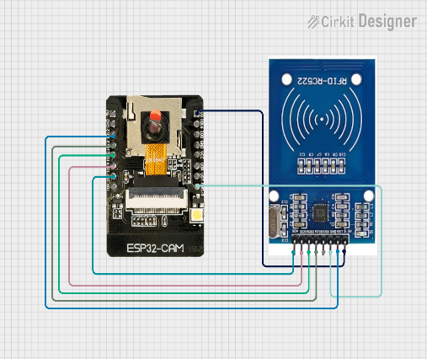

6. Workflow
- IR sensor detects a person → ESP32 wakes up
- User enters PIN or scans RFID card
- Access is granted if PIN/UID matches
- LED feedback is shown for authorized access
- No activity → system enters deep sleep
Image placeholder: Workflow flowchart diagram.

